Experiment:31 Date:18/08/2027

BACKWARD CHAINING

Aim
To write a Prolog program to implement backward chaining.

Algorithm
- Start with the required goal.
- Search for a rule that can prove the goal.
- Check the conditions of that rule.
- Recursively prove the required conditions.
- Display success when the goal is proved.

Program
bird(tweety).
has_wings(tweety).

can_fly(X) :-
bird(X),
has_wings(X).

is_safe(X) :-
can_fly(X).

OUTPUTS:
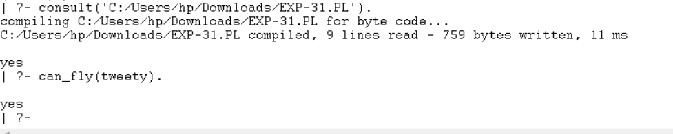

RESULTS:
Thus, backward chaining was successfully implemented in Prolog.

